1. Understanding the Data
This is the phase we just completed.
It includes:
- Loading the dataset
- head()
- Shape → 10683 × 11
- Column names
- Data types
- info()
- Statistical summaries
- value_counts()
- Understanding what each column represents
- Identifying the target variable
- Initial decisions about which features may be useful

2. Data Preprocessing
We are entering this phase now.
Here we'll actually modify/transform the data:
- Check and handle missing values
- Check and remove duplicates
- Date transformation
- Time transformation
- Duration conversion
- Total Stops conversion
- Handle/drop Route
- Handle/drop Additional_Info
- Encode categorical variables
- Final feature selection

3. Exploratory Data Analysis (EDA)
After preprocessing:
- Univariate analysis
- Bivariate analysis
- Target distribution
- Numerical feature relationships
- Categorical feature vs. price
- Correlation analysis
- Outlier analysis
- Extract useful insights

4. Feature Engineering / Feature Selection
Depending on what we discover during preprocessing and EDA, we'll create/select the final features.

5. Model Building
- Train-test split
- Baseline model
- Multiple regression algorithms

6. Model Evaluation & Comparison
- MAE
- MSE
- RMSE
- R²
- Compare models

7. Hyperparameter Tuning
Improve the best-performing model.

8. Final Model & Prediction
Select the final model and demonstrate predictions.

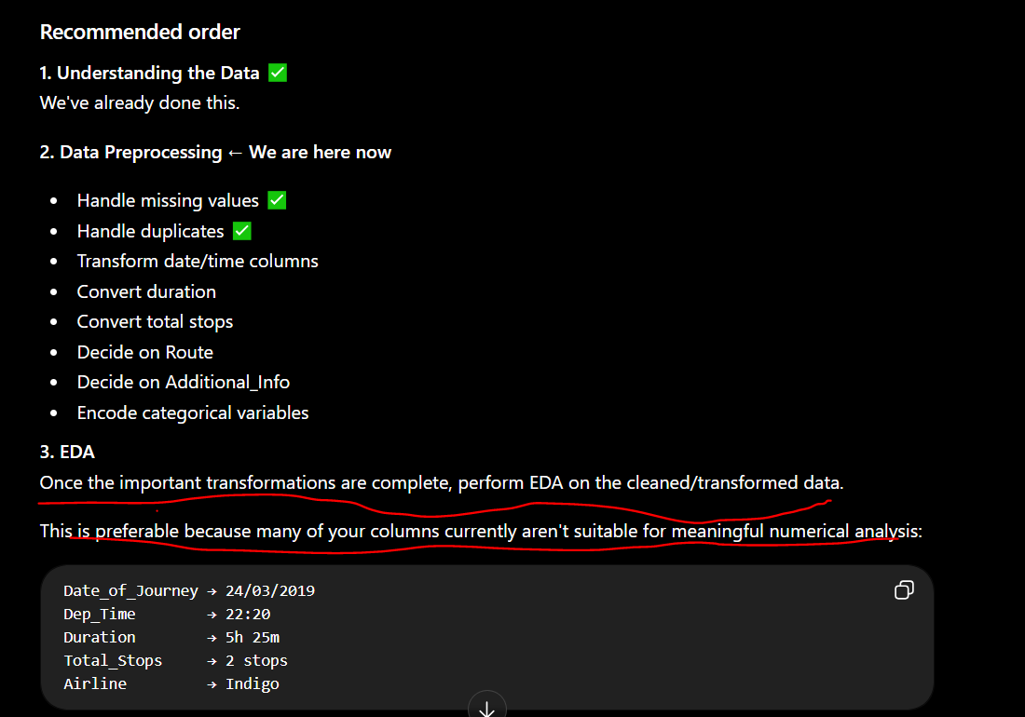

Why this order?
- EDA: Identify patterns and relationships visually.
- Hypothesis Testing: Statistically verify whether selected observations are significant.
- Feature Engineering: Use relevant findings to decide which features to create or retain.
- Preprocessing: Encode, scale, and prepare features for machine learning.

What this code does
- corr → measures the strength and direction of the linear relationship.
- p_value → tells us whether the observed relationship is statistically significant.
- We use 0.05 as the significance level.
- If p_value < 0.05 → Reject H₀.
- If p_value >= 0.05 → Fail to reject H₀.

o we should not blindly treat every numerical column as a continuous measurement.
For this project, I'd keep them as numerical features initially and evaluate the models. We can also discuss cyclical encoding later if we want to make the feature engineering more sophisticated:
month → sin(month)
month → cos(month)
This represents the fact that December and January are adjacent in the yearly cycle.
But I wouldn't introduce that complexity immediately. Let's first build a clean baseline pipeline.

